**Speed Control of DC Motors - Describe and compare various methods of speed control of DC motors**

Wang Zihao

A0204706M

Group 4b

National University of Singapore, Computer Engineering

CG1111 Engineering Principles and Practice I

18 October 2019

**Summary**

This report will explain the structure and basic principles behind a DC motor, describe three different methods of speed control and compare these three methods regarding to their advantages and disadvantages.

**Structure**

DC motors is a device that converts electrical energy to mechanical energy, by using the force created by interacting magnetic fields. Normally, a DC motor contains six basic parts – axle, rotor, stator, field magnets, commutators and brushes [1].

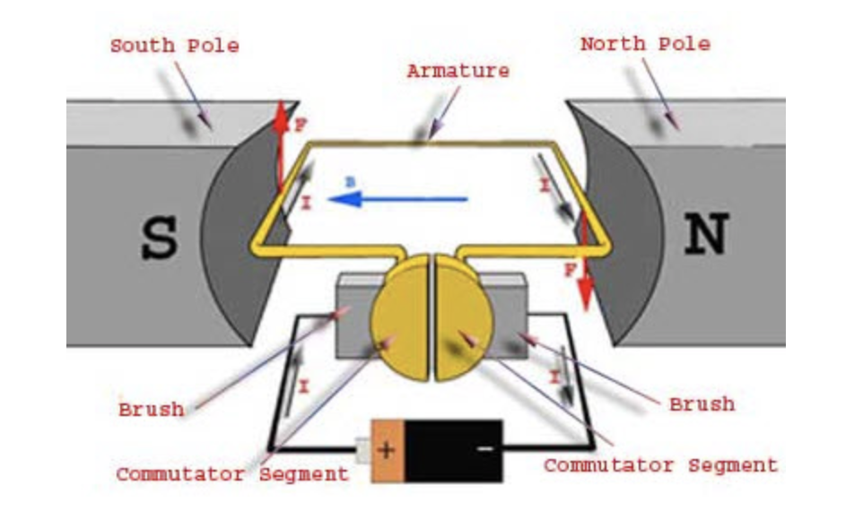

Fig.1.1 Side View of DC Motor [4]

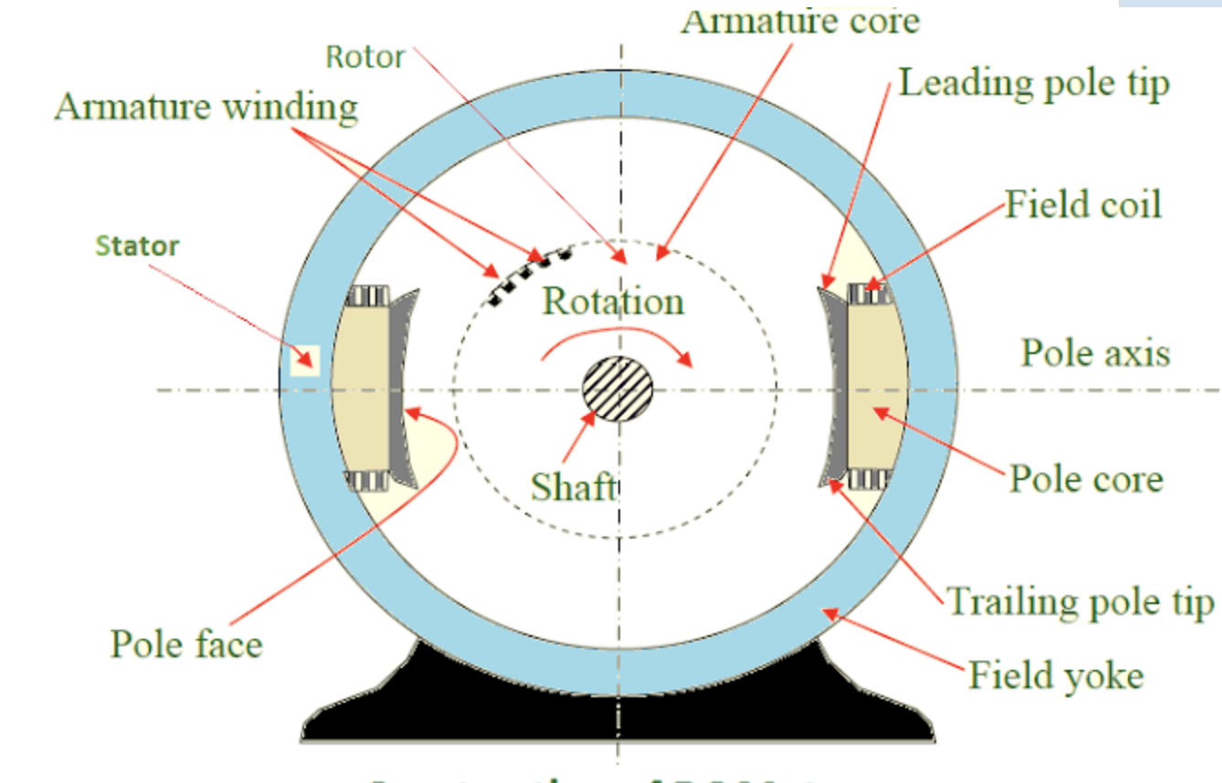

Fig.1.2 Cross Section of DC Motor [1]

**Principles**

According to Fleming’s Left Hand Rule, the middle finger indicates the direction of the current flowing into the armature, the index finger indicates the direction of the magnetic field line and the thumb indicates the direction of the force acting on the armature, there will be a net force acting on the armature, causing it to rotate cloackwise or anticlockwise depending on the direction of the force. When the armature moves from one side of a brush to the other, the current in that armature is reversed. Thus, the direction of the force acting on the armature will be reversed, which ensures that the armature rotates continuously in a single direction. According to Faraday’s Law of Electromagnetic Induction, there will be a back emf induced in the armature and according to Lenz’s Law, the current induced in a circuit due to a change or a motion in a magnetic field is so directed as to oppose the change in flux and to exert a mechanical force opposing the motion [2].

**Equations**

Firstly, Vsupplied = Eb + Varmature, where Vsupplied indicates voltage supplied, Eb­ indicates back emf and Varmature indicates armature voltage. Secondly, Eb ­ = KΦω, where K is a constant, Φ is magnetic flux and ω is angular speed of a DC motor. By rearranging these two equations, a equation ω = K can be derived, which can lead to three different relationships regarding to the angular speed of the motor. Thus, three different methods of speed control of a DC motor can be achieved [3].

**Armature Control Method**

The speed of the motor can be controlled by varying the armature voltage, and by varying the armature resistance. In this case, a variable resistor is connected in series with the armature. When the resistance of the variable resistor increases, the potential difference across it decreases. By Potential Divider Principle, the potential difference across the armature decreases. From the derived equation, angular speed is inversely proportional to the armature voltage. When the armature voltage increases, angular speed of the motor decreases [4].

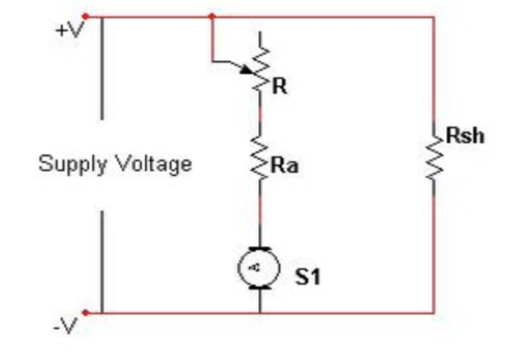

Fig.2.1 Armature Control Method [4]

**Flux Control Method**

The speed of the motor can be controlled by varying the flux, and by varying the current through field winding. In this case, a variable resistor is connected in series with the field winding, which is connected to the electromagnet. When the resistance of the variable resistor increases, the current flowing through the field winding decreases. As the magnetic flux is directly proportional to the current, the magnetic flux decreases. From the derived equation, angular speed is inversely proportional to the magnetic flux. When the magnetic flux decreases, angular speed of the motor increases [4].

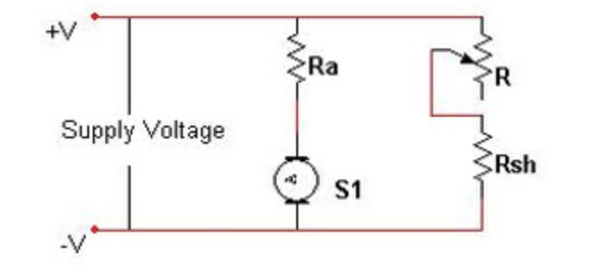

Fig.2.2 Flux Control Method [4]

**Voltage Control Method**

The speed of the motor can be controlled by varying the supplied voltage. This can be done by applying Pulse Width Modulation(PWM) [4].

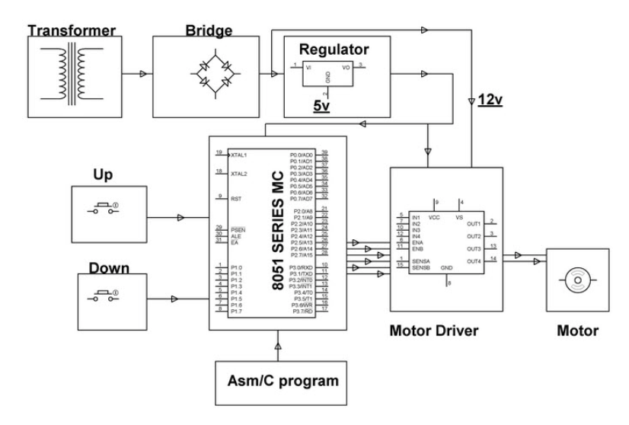

Fig.2.3 Voltage Control Method using PWM [4]

The motor driver contains a H bridge circuit which is used to control the direction of the current flowing through the motor, thus controlling the direction of the rotation of the armature. The H bridge preferentially works under high frequency as the switch can be turned on and off more frequently, and thus the output waveform will behave more like DC. When the switch S1 and S4 are closed, the current flows from the left side of the motor to the right, thus the motor will rotate in one direction either clockwise or anticlockwise. When the switch S2 and S3 are closed, the current flows from the right to the left, thus the motor will rotate in the opposite direction, comparing to switching off S1 and S4 [5].

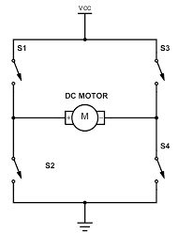

Fig.2.4 H bridge [6]

In addition, an Arduino Uno is connected to the H bridge and by uploading codes and commands to the Arduino Uno, the duration and the exact switch to be turned on can be controlled. Thus the duty cycle of the circuit can be controlled. With a higher duty cycle, average output voltage to the DC motor will be higher. According to the derived equation, voltage supplied is directly proportional to the angular speed. Thus a higher voltage supplied will lead to a higher angular speed of rotation [6].

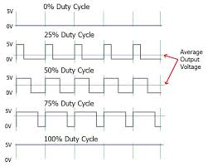

Fig.2.5 PWM signals for different duty cycles [6]

**Comparison**

A cost-benefit analysis will be carried out to compare among these three methods. For the Armature Control Method, huge power loss is involved due to its usage of resistor in series with the armature (P=I2R). Thus it is inefficient and Flux Control Method is introduced to prevent the power loss [4]. Flux Control Method is efficient as power loss is low due to relatively small current in field winding. However, it affects commutation due to the additional component connected in series with the field winding, and it cannot provide speed control in the desirable range as the extent of decreasing and increasing of the magnetic flux cannot be determined [4]. Hence, a third method is introduced which is Voltage Control Method using Pulse Width Modulation(PWM). This method is efficient as the potential difference across the switch is almost zero thus the power loss of turning on and off the switch is insignificant. Moreover, specific voltage applied to the motor can be monitored by varying the coding uploaded to the Arduino Uno. Economically, PWM involves lower cost [4] [6].

**Conclusion**

From the comparison shown above, a solution can be concluded that Voltage Control Method is the method that commonly used in the real world today due to the advantage associated with it.

# Bibliography

|  |  |
| --- | --- |
| [1] | abs, "Working Principle of DC Motor," Blogger, 2 January 2013. [Online]. Available: http://workingprincipalofdcmotor.blogspot.com/2013/01/construction-of-dc-motor.html. [Accessed October 2019]. |
| [2] | NUS, "DC Motors," [Online]. Available: http://uav.ece.nus.edu.sg/~bmchen/courses/EG1108_DCmotors.pdf. [Accessed October 2019]. |
| [3] | K. Daware, "Speed Control Methods of DC Motor," 2016. [Online]. Available: https://www.electricaleasy.com/2014/01/speed-control-methods-of-dc-motor.html. [Accessed October 2019]. |
| [4] | T. Agarwal, "Know About 3 Important Ways for DC Motor Speed Control," Elprocus, 07 July 2019. [Online]. Available: https://www.elprocus.com/what-are-the-best-ways-to-control-the-speed-of-dc-motor/. [Accessed October 2019]. |
| [5] | A. Raj, "What is PWM: Pulse Width Modulation," CircuitDigest, 19 September 2018. [Online]. Available: https://circuitdigest.com/tutorial/what-is-pwm-pulse-width-modulation. [Accessed October 2019]. |
| [6] | Ø. N. Dahl, "What is an H-Bridge," BuildElectronicCircuits, 5 December 2018. [Online]. Available: https://www.build-electronic-circuits.com/h-bridge/. [Accessed October 2019]. |